Tree Topology

What Is Tree Topology?
# Source: AI Source: Provided by: [Data Path: Persons Table -> ID Column: 1, Name_En Column: Motasem Essam] -> From: [ChatGPT] on [12/18/2025]
A Tree Topology is a hybrid network topology that combines characteristics of both Star and Bus topologies. Devices are connected in a hierarchical or branching structure, much like a family tree.

🧠 Simple Definition:
# Source: AI Source: Provided by: [Data Path: Persons Table -> ID Column: 1, Name_En Column: Motasem Essam] -> From: [ChatGPT] on [12/18/2025]
In a tree topology, there is a root node (usually a central switch or router), and other nodes are connected in a branching pattern across different levels.

🖼️ Visual Example:
# Source: AI Source: Provided by: [Data Path: Persons Table -> ID Column: 1, Name_En Column: Motasem Essam] -> From: [ChatGPT] on [12/18/2025]
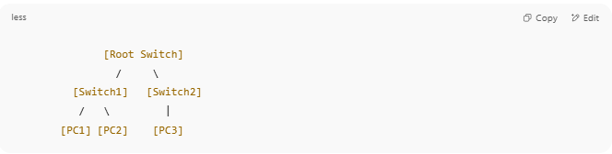
[Root Switch]
/ \
[Switch1] [Switch2]
/ \ |
[PC1] [PC2] [PC3]

- Top-level = central/root switch
- Mid-level = distribution switches
- Bottom-level = end devices (PCs, printers, etc.)

🧩 Components
# Source: AI Source: Provided by: [Data Path: Persons Table -> ID Column: 1, Name_En Column: Motasem Essam] -> From: [ChatGPT] on [12/18/2025]
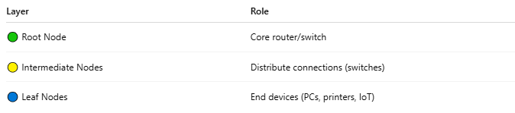

Layer | Role
🟢 Root Node | Core router/switch
🟡 Intermediate Nodes | Distribute connections (switches)
🔵 Leaf Nodes | End devices (PCs, printers, IoT)

✅ Advantages
# Source: AI Source: Provided by: [Data Path: Persons Table -> ID Column: 1, Name_En Column: Motasem Essam] -> From: [ChatGPT] on [12/18/2025]
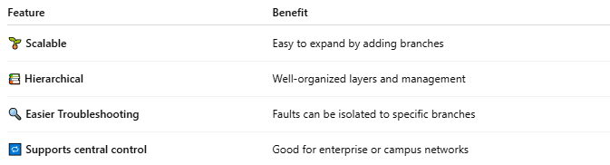

Feature | Benefit
🌱 Scalable | Easy to expand by adding branches
📚 Hierarchical | Well-organized layers and management
🔍 Easier Troubleshooting | Faults can be isolated to specific branches
🔁 Supports central control | Good for enterprise or campus networks

❌ Disadvantages
# Source: AI Source: Provided by: [Data Path: Persons Table -> ID Column: 1, Name_En Column: Motasem Essam] -> From: [ChatGPT] on [12/18/2025]
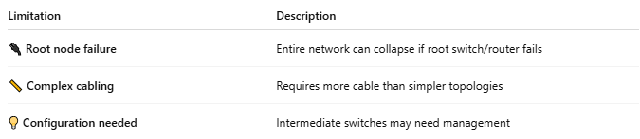

Limitation | Description
🔌 Root node failure | Entire network can collapse if root switch/router fails
📏 Complex cabling | Requires more cable than simpler topologies
💡 Configuration needed | Intermediate switches may need management

🛠️ Common Use Cases
# Source: AI Source: Provided by: [Data Path: Persons Table -> ID Column: 1, Name_En Column: Motasem Essam] -> From: [ChatGPT] on [12/18/2025]
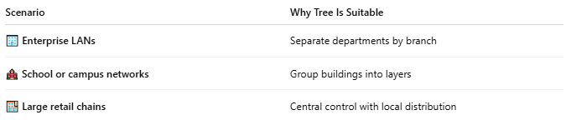

Scenario | Why Tree Is Suitable
🏢 Enterprise LANs | Separate departments by branch
🏫 School or campus networks | Group buildings into layers
🏬 Large retail chains | Central control with local distribution

✅ Summary
# Source: AI Source: Provided by: [Data Path: Persons Table -> ID Column: 1, Name_En Column: Motasem Essam] -> From: [ChatGPT] on [12/18/2025]
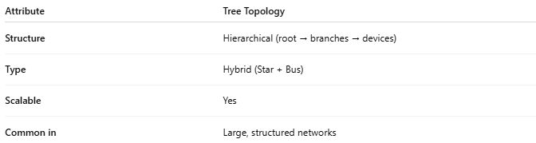

Attribute | Tree Topology
Structure | Hierarchical (root → branches → devices)
Type | Hybrid (Star + Bus)
Scalable | Yes
Common in | Large, structured networks

